DTS/THR/01/2025-2026
Date:23/07/2025

To,
THE PRESIDENT/SECRETARY
PANTHALLUR KSHEEROLPADHAKA SAHAKARANA SANGHAM
LTD NO. R 234 (D) APCOS, PANTHALLUR.PO,NELLAYI
THRISSUR - 680305
PH: 9400943622

Respected Sir,
DTS is a software house operating in the IT industry for the past 11+ years. We have executed projects in the local as well as overseas market and has got a good clientele State-wide. Our operations include I.T consulting, Software Development and Industrial Automation.

Pertaining to the current scope, DTS has got more than 11 years experience in the field of implementing Automatic Milk Collection Stations at various Milk Co-operatives all over Kerala and have got more than 829 installations in the State so far. We are the exclusive dealers for “ESSAE” ,“PROMPT” Milk Analyzers, in Kerala.
We are submitting a detailed proposal on ‘the implementation of Milk Analyzer at Dairy Co-operatives’ herewith for your kind perusal. Should you have any queries in this regard, please feel free to contact us at any time. We thank you for giving us the opportunity to serve you and ensure you of our wholehearted and un-interrupted service and support at all times.

Thanking You

For -DAIRY TECH SOLUTIONS PVT.LTD
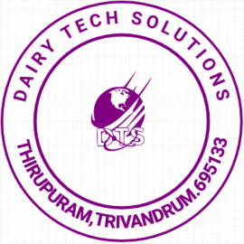
SAYANA
Customer Support Manager

Milk Analyzer-Essae MA-815
It is the first 100% Indian Milk Analyzer that assures accurate results and awesome repeatability.

Salient Features :
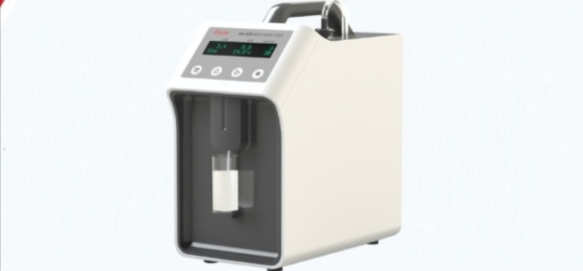
- Easy availability of spares
- Replaceable parts
- Easy operation, cleaning & calibration
- Rugged yet lightweight framework
- Elegant and compact design
- Dependable structure
- Cost effective operation due to very low power consumption
- RS232 interface and POS Printer Support
Specifications :
Brand | Essae
Model | MA-815, MA-815(SS)
Technology | Ultrasonic Sensor
Measuring Time | 38 sec @30°C Milk Temperature
Milk Temperature | 0 ~ 40°C
Milk Sample Volume | 25 ml
Display | 2 x 20 Character LCD Display with Green Backlight
Measuring Parameters :
Fat | From 0.5% to 15% with accuracy +/- 0.1%
Solid not Fat (SNF) | From 3% to 15% with accuracy +/- 0.2%
Added water | From 0% to 100% with accuracy +/- 3%
CLR | From 20 to 40 with accuracy +/- 1%

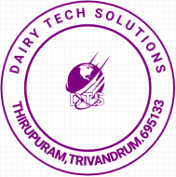

The Total solution consists of the following components.
Items | Brand | Nos
MILK ANALYZER | Essae | 1

DTS Contact:
Person | Email | Contact Nos.
SAYANA | dairytechsolutions@gmail.com | 9207011151,9961011151
Office :
TRIVANDRUM: DAIRY TECH SOLUTIONS PRIVATE LIMITED
T.P.X-476,LOVE LAND,GROUND FLOOR, NEAR KARODE-BY PASS
NEYYATTINKARA,THIRUVANANTHAPURAM,THIRUPURAM,
KERALA,INDIA-695133
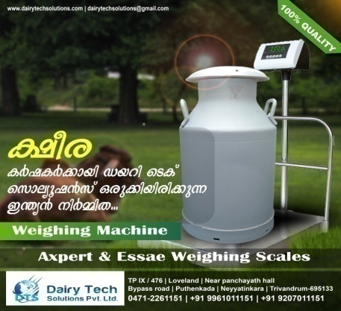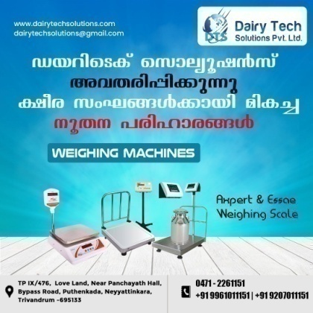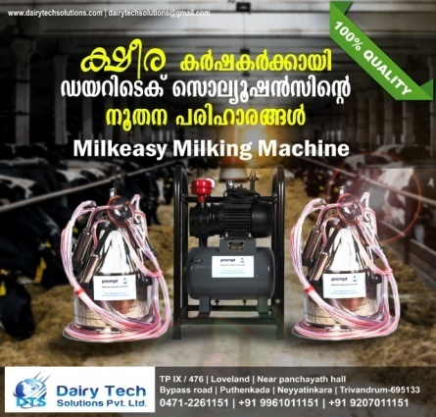

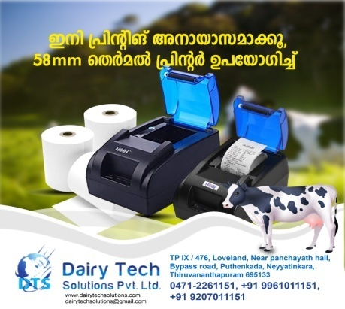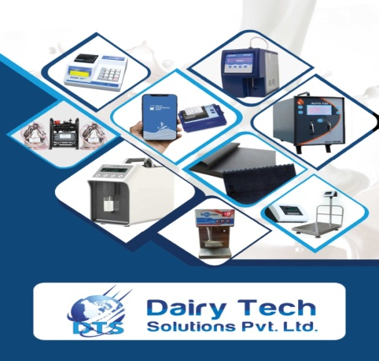



TERMS AND CONDITIONS

Onsite Support
We have got a service technician in place for providing adequate support for the APCOS in time.

Payment Terms
100% on installation
Delay in payment beyond 10 days from the date of installation or 15 days from date of delivery, whichever is earlier will attract an interest rate of 5% of order value per week.

Assumptions
DTS will re-estimate schedule and cost at the end of the Functional Specifications phase, if the scope of the project increases significantly or if the underlying requirements are of complex nature.

Warranty
DTS warrants that the deliverables will meet specifications. The period of warranty is limited to 13 months from the date of delivery or 12 months from the date of installation, whichever is earlier. The guarantee however does not cover any damage resulting from normal wear and tear or improper attendance or mishandling of the equipment during repairs by personnel other than the supplier or his authorized agents. Except for the warranties mentioned above, DTS excludes and disclaims all conditions, warranties, statements, whether express, implied or statutory.
This warranty however does not cover glass, rubber components and load cell used in the various equipments. This warranty also does not cover defects arising out of willful damage/operator error/negligence, power line related defect, damages by rats/rodents etc. Such repairs will be on a chargeable basis. The following cases will not be covered under the warranty clause and repair/replacement of these will be on chargeable basis.
Any services in connection with or arising out of relocation of the product or the addition. Development of additional Modules other than what is there in the offered software. Software update or upgrade other than at the initiative of DTS. Conditions, or any repair or attempt to repair or modification carried out to the product or the software by any person other than an authorized representative of DTS. Any damage resulting from normal wear and Tear or improper attendance or mishandling of the equipment at the Purchaser’s premises or during repairs by personnel other than the supplier. Changes or enhancements in product features. Physical damages due to inappropriate maintenance. Damages caused by Lightning. Damages caused by any power line related faults. Damage to the sensor of analyzer due to inappropriate cleaning. Damage caused by Rat, Cockroach or other harmful insects. Damages to the load cell due to wet conditions.
Annual maintenance Charges will be as follows:
2nd Year - @ 10.0% of the total cost per annum.
3rd Year - @ 11.5% of the total cost per annum.


